**NEW USER ACCESS REQUEST FOR EC LINK POST GO-LIVE.**

* New users will go to <https://carelink.ourepic.ca/EpicCareLink-PRD/>
* Click on “Request New Account”

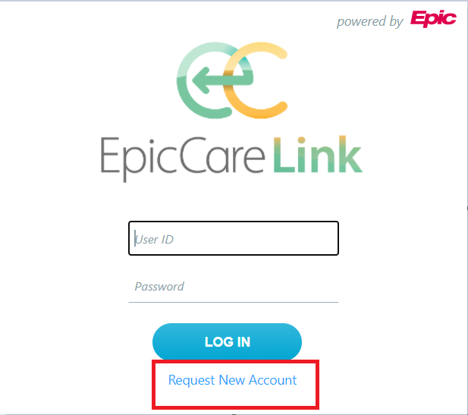

* Choose the correct option based on role.

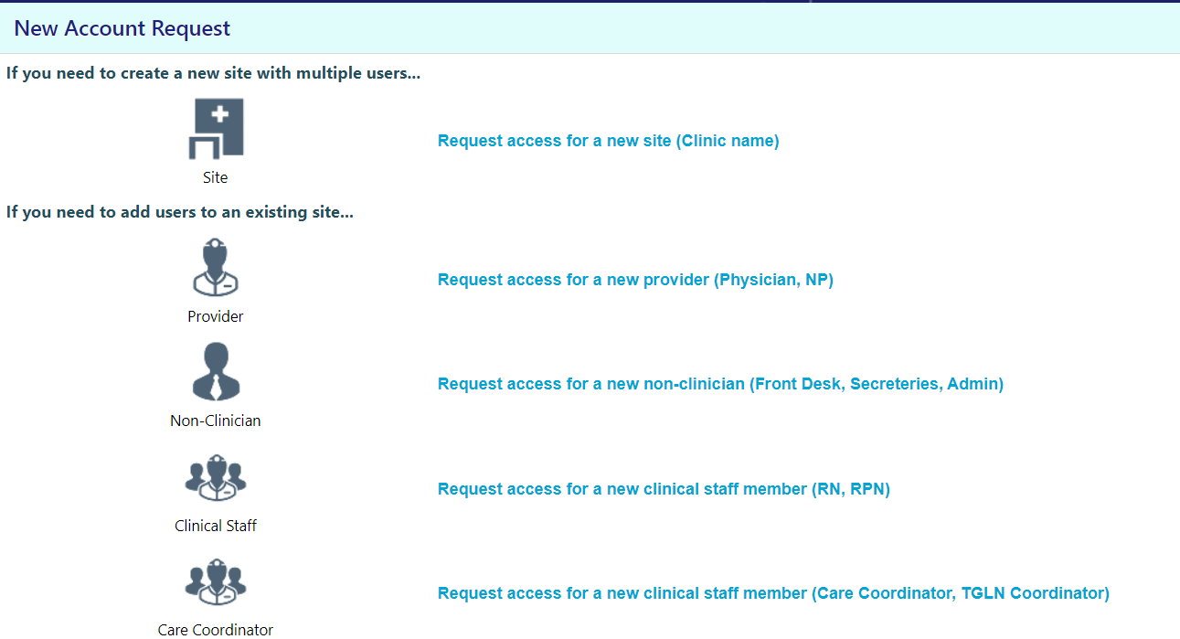

* Fill up all the required information including the hospital you are associated with and submit the form.

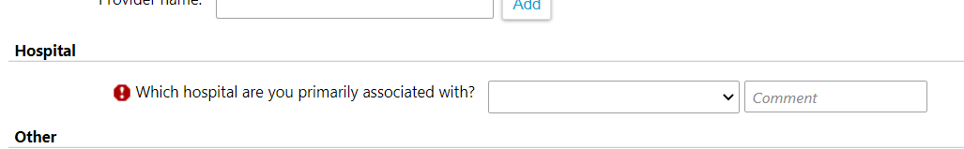

* The access request will be routed to hospital staff (designated IT or Medical Affairs) based on the response to question above through In-Basket message.
* Hospital staff is responsible for vetting out the request and making sure all the information is correct and then create a Manage Engine ticket for EC Link team for user creation.
* EC Link team will create a user and send the user information back to hospital staff through Manage Engine.
* Hospital staff to disseminate info back to requesting users.